STP510 Tentative Research Prospectus

Yunji Woo

Research Question

Large-scale projects, which require big budgets, big staffs, big machines, and often big laboratories are usually funded by national governments or group of governments, so called ‘Big Science’. The contributions made by big science projects to industrial innovation are, however, often both unpredictable and underappreciated. Upstream in creating and developing the construction and engineering capabilities and innovations in supply chains to deliver large and complex scientific facilities and equipment. They extend downstream through commercialization and industrial application of innovative technologies and outcomes that emerge from science.

The centralization of scientific research in large laboratories has become a cost-effective strategy. High-technology warfare has turned support of scientific research and promised to turn scientists and engineers into beneficiaries of war largesse. With the increasing importance on national security priority, big science research had developed with geo-political approaches.

Because of its high relevance to military, aerospace industry is one of the major examples of big science. The basic research and development of military aircrafts, rocket launches, and satellites were led by government funding.

However, the infrastructure of aerospace industry is facing a new phase: New Space era. The market demand for small satellite and rocket is rapidly growing, and the prices are up to mate the requirements based on technology development such as reusable rockets and small satellite constellation. The international market increase on military aircraft and missiles have also boosted industrial innovation. Also, the growing civil demands on future air transportations such as UAM, drone, and PAV would create another market interest.

The new space innovation evolved from western countries, especially in USA, and China is experiencing policy isomorphism; to change the innovation initiative from government to engineering firms. South Korea is not experiencing direct isomorphism because the market demands on aerospace industry is small yet. However, the small success of aerospace start-ups and requirements on 5G to 6G communication would lead market innovation.

The innovation in space sector is being led three-fold: Upstream, Downstream, and Instream.

So, these are my research question: Does change of initiatives, government centric to commercial firm, provoke rapid innovation especially on space sector? The strengthened supply chains and infrastructures could contribute on sectoral innovations, which would led regional innovation systems. Then, what would be the role of policy in big science and emerging technology?

In this research, I am planning to examine how the traditional government industry relationship was formulated, and how infrastructure is reshaped through new space innovation.

1. The new space innovation

Space exploration and exploitation traditionally required extensive budget and long-term development period, but risky and unexpectable. As the commercial use of satellite information diversified and turned profitable, firms are being actively investing space industry. The global industry of private companies and entrepreneurs primarily targeting commercial customers are called as New Space. There are hundreds of entrepreneurs that are different significantly from NASA and the mainstream aerospace industry. The space innovation is categorized three-fold: Upstream, Downstream, and Instream.

1. Upstream

Upstream calls for space-for-space technology, with rocket launches and high-tech satellite payloads. The upstream part of the sector is undergoing a rapid transformation. Major technology innovation such as 3D printing, reusable rockets, use of smart composites.

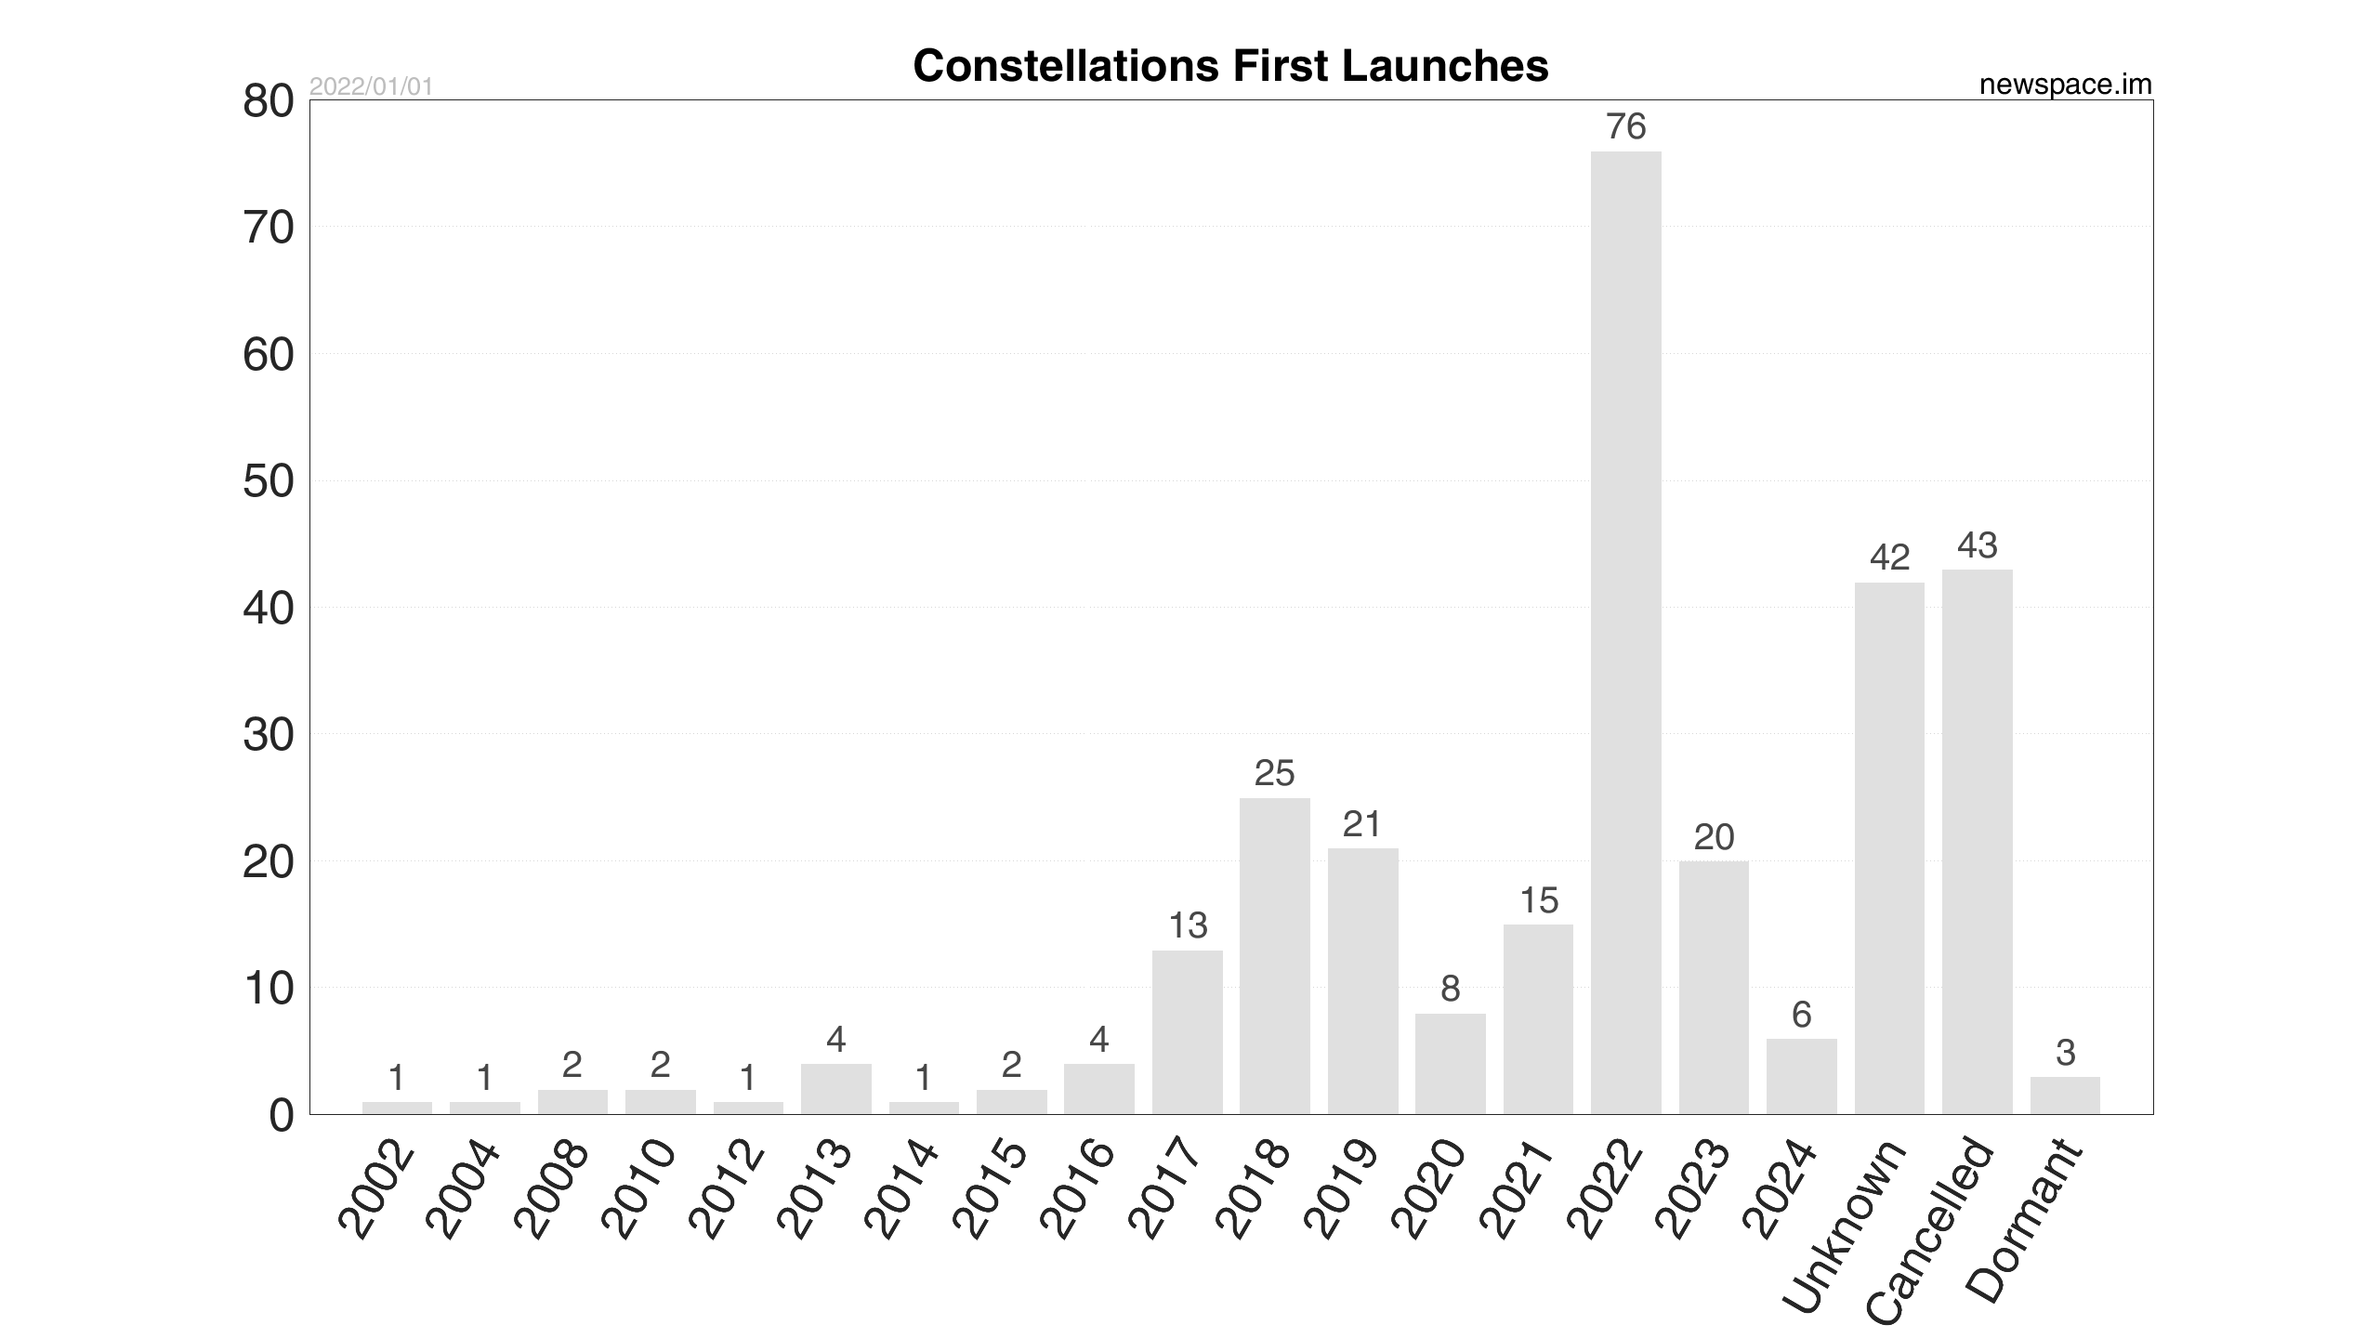

<Satellite constellation launches ref) newspace.im>

There are numerous rocket startups such as Rocket Lab, Astra, and ispace, which have got space-focussed funding sources for startups, incubators, accelerators, competitions and VCs. Venture Capitals are focusing space industry as a new emerging technology.

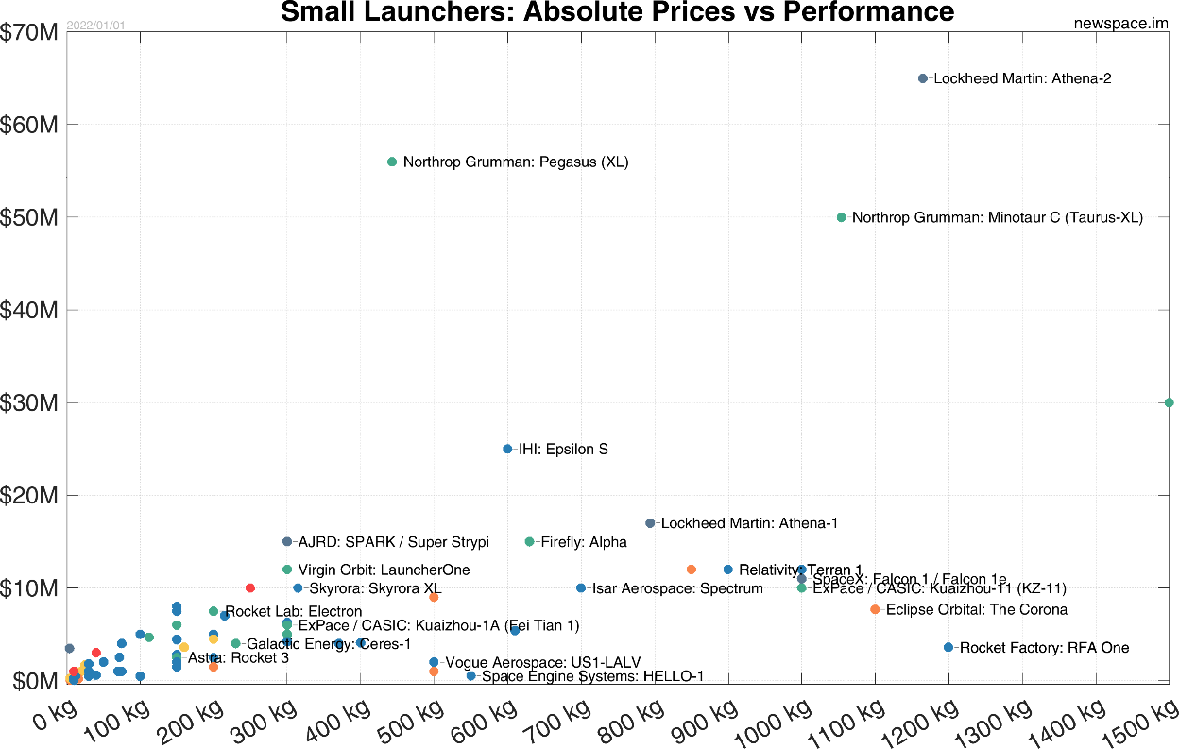

<prices vs performance for small launchers>

1. Downstream

The downstream market contributes job and revenue creation and the provision of services. GNSS markets, applications and data.

According to GSA GNSS Market Report, the global revenue generated by the GNSS downstream market is forcast to reach EUR 150 billion in 2019 and increase EUR 325 billion in 2029.

Autonomous vehicle highly ~~~, GNSS enabled in vehicle system.

1. Instream

Instream market is originated from the demand of space sectors. The platform such as data server cloud, project management tools, ~~~ would be major example. There are also healthcare and space migration projects relates to instream innovation. The resources, interaction ~~~~ Space 4.0 marks a new era; in which space is an enabler. It enables knowledge, jobs and growth, decision and policymaking, inspiring and motivating the next generations.

1. How the traditional industry is constructed? 산학연과 정부

The actors in innovation systems may be organizations such as firms, universities, financial institutions, governmental agencies, groups of organizations, or individuals. They interact through different forms of communication, exchange, cooperation, competition, and command.

1. Public Procurement Innovation

Upstream sectors usually provide public procurement for innovation in the performance of the suppliers. The space programs of public agencies, and particularly European agencies such as the ASI or the ESA, mainly define the infrastructure scientific/performance/cost requirements in their procurement activity, and leave the responsibility for the technological project.

The belief that PPI is capable of improving companies' economic performance and their innovative potential is supported by a broad economic literature.

the contracting authority bears the risks related to investments in research & development and innovation

Such risk can deter private companies from bearing innovation costs, which leads to a suboptimal level of innovation

1. Partnership with firms and public agencies

The benefit coming from the partnership with research institutes and infrastructures and public agencies are not limited to the positive effects which they may derive from the procurement relationship. Effect of partnership between contracting authority and research institution, public research body or university department is less easy to identify.

Academic research plays a key role in the industrial innovation process.

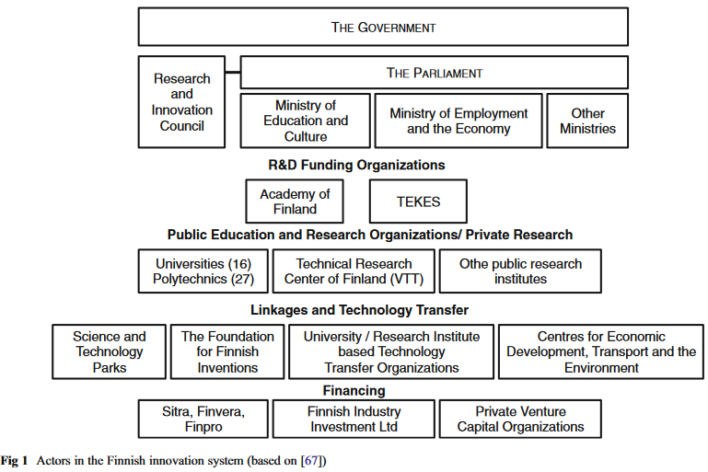

Ref) Pihlajamaa, M. et al. (2013) ‘Requirements for innovation policy in emerging high-tech industries’, European Journal of Futures Research, 1(1), pp. 1–14.

1. Market demand changes,

1. Innovation in big science

How investing in big science benefits industrial innovation. Big sciences have budgets of hundreds of billions of dollars and produce major benefits for industry.

These benefits are allied to activities undertaken midstream, or instream, through the myriad collaborations and solutions provided by industry necessary for the conduct of large-scale experiments. Valuable skills are developed in all stages of big science projects that have potential use in industry.

1. Case study in South Korea

The industry trend graph configured with domestic aerospace manufacturing companies: KAI, Korean Air, Hanhwa and etc. The aerospace industry is a system integration program that includes structures, avionics, material engineering. The report on import, export, and domestic demands is used as an index of aerospace industry capacity. The aviation industry has a long investment tenure (about 20 years) and a large facility investment is required for production. The maintenance infrastructure on civil aircraft declined sharply due to the impact of COVID-19, but the production of engine parts increased.

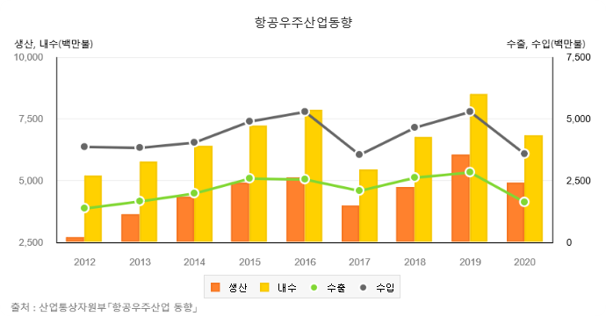

<Aerospace industry trend in Korea ref) index.go.kr>

Future policy directions include participation in international joint development for the recovery of civilian exports, support for key technology development and overseas market advancement, promotion of technology development related to the KF-21 project and performance improvement of military aircraft (FA-50), future aviation such as UAM, drone, and PAV Promotion of technology development to preoccupy the market.

The traditional aerospace industry is constructed with big firms closely connected with military, on the other hand, the space industry is being lead by start-ups. Upstream start-ups are developing satellite, launcher, and ground systems, and downstream start-ups are contributing on satellite information applications and scientific research.

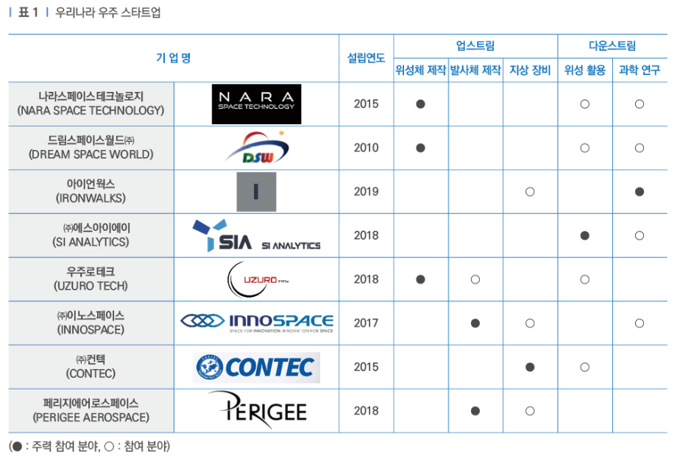

<Space start-ups in South Korea ref: <http://webzine.koita.or.kr/202109-specialissue/>뉴-스페이스-시대의-핵심-우주-스타트업의-현황과-과제>

To attract investment and build an ecosystem that reflects corporate value by raising the awareness of private investors as a space company. Rather than suffering from difficulties in securing investment funds, the depreciation of corporate values in the market and an understanding of the underdeveloped industry by private investors in the space sector.

Support related to domestic and overseas market development is needed. Although we are making efforts to develop overseas markets, we are facing difficulties in developing new markets because we prioritize domestic products. Geo-political

The space industry requires more development time and capital to develop than other technologies. It requires regular and in-depth testing. It can take more than five years from the inception of development to the time it comes to market, with high risks. A start-up support policy that reflects the characteristics of the space sector is needed.

Knowledge development and diffusion

Aerospace industry is one of the main drivers of the economies of Portugal and Andalusia(Spain), where it generates more than 30,000 jobs and sales of over 4000 million euros. The study analyses the needs and capacities regarding innovation of companies and R&D Centers in the aerospace sector of both regions. Regional and cross-border collaboration opportunities have been detected utilizing the survey data.

1. Enabling private individuals to take on greater risk than would be tolerable for government-employed astronauts. Decentralized, marked oriented space sectors.

An instructive analogy can be found in how NASA works with its contractors: In the mid-2000s, NASA shifted from using cost-plus contracts (in which NASA shouldered all the economic risk of investing in space) to fixed-price contracts (in which risk was distributed between NASA and their contractors). Because of private companies’ greater tolerance for risk, this shift catalyzed a burst of activity in the sector — sometimes referred to as “New Space.” A similar shift in how we approach voluntary risk-taking by private-sector astronauts may be necessary in order to launch the space-for-space economy.

1. Judiciously implementing government regulation and support.

developing a stable space economy will depend on government regulation and support. NASA and the U.S. Commerce and State Departments’ recent recommitment to “create a regulatory environment in [low-Earth orbit] that enables American commercial activities to thrive” is a good sign that the government is on a path of continued collaboration with industry, but there’s still a long way to go.

Governments should start by clarifying how property rights over limited resources such as water on Mars, ice on the Moon, or orbital slots (i.e., “parking spots” in space) will be governed. Recent steps — including NASA’s offer to purchase lunar soil and rocks, last April’s Executive Order on the governance of space resources, and the 2015 Commercial Space Launch Competitiveness Act — indicate that the U.S. government is interested in establishing some form of regulatory framework to support the economic development of space.

In 2017, Luxembourg became the first European country to establish a legal framework securing private rights over resources mined in space, and similar steps have been taken at the domestic level in Japan and the United Arab Emirates. Moreover, nine countries (though Russia and China are notably missing) have signed the Artemis Accords, which lay out a vision for the sustainable, international development of the Moon, Mars, and asteroids. These are important first steps, but they have yet to be clearly translated into comprehensive treaties that govern the fair use and allocation of scarce space resources among all major spacefaring nations.

In addition, governments should continue to fill the financial gaps in the still-maturing space-for-space economic ecosystem by funding basic scientific research in support of sending humans to space, and by providing contracts to space startups. Similarly, while excessive regulation will stifle the industry, some government incentives, such as policies to reduce space debris, can help reduce the costs of operating in space for everyone in ways that would be difficult to coordinate independently.

3. Moving beyond geopolitical rivalries.

Finally, the development of the space-for-space economy must not be undermined by earthly geopolitical rivalries, such as that between the United States and China. These conflicts will unavoidably extend into space at least to some extent, and military demand has long been an important source of funding for aerospace companies. But if not kept in check, such rivalries will not only distract attention and resources from borderless commercial pursuits but also create barriers and risks that hamper private investment.

On earth, private economic activity has long tied together people whose states are at odds. The growing space-for-space economy offers exceptional potential to be such a force for unity — but it’s the job of the world’s governments not to get in the way. A collaborative, international approach to establishing — and enforcing — the rule of law in space will be essential to encouraging a healthy space-for-space economy.

Conclusion

The impact of policy on high-tech sectors is usually higher than low-tech companies. Relevant technological spillover.

The goal of innovation policy is to select a desirable future and facilitate its realization. Innovation policy can never be fully technology neutral and policies often align to support incumbent technological regimes obstructing the development of new industries. Innovation policy’s capabilities to promote emerging industries.

<Sectoral systems of innovation>

Different actors interacts to promote creation of technological innovations. Falcilitates diffusion or applications of technological innovations. Sectoral innovation systems are innovation takes place in different sectoral environments. Focus on certain sectors of the economy.

Innovation differs across sectors in terms of characteristics, sources, actors involved, organizational activities. Dimensions to understand innovation and its differences. : Knowledge base, actors involved, links and relationships among actors, institutions.

Pavitt(1984) propsed four types of sectoral pattern for innovative activities. Supplier-dominated, Scale-intensive, Specialized suppliers, science-based. The space sector has both specialized suppliers and science-based characteristic, that has high rate of product and process innovations. The source of innovations are internal R&D, scientific research at universities and public research lab. Specialized suppliers sectoral innovation focuses on the performance improvement, reliability, and customization. The source of innovations are tacit knowledge, experience of skilled technicians, and user-producer interaction.

Current space innovations are research based, but government led projects are long-term, and 공백기가 길다. That makes tacit knowledge 단절되다 between generations. The special technicians are retired by project to project. The user of the product are usually government, that enables interaction between user-producer. Also, this makes localized and interactive natural knowledge. The government led projects are usually related to national security and militaries, that does not allow patents for security.

The sectoral system framework propose dynamic view of innovation in sectors. There are three dimensions of sectors. Knowledge and technological domain, Actors and networks, and institutions. The network of actors are constituted by universities and government agencies, concretely linked with firms, users, and suppliers. They create institutional norms, rules, and laws. – 표준, 절차, ~~~.

Reference

1. Florio, M. et al. (2022) The Socio-Economic Impact of Public Policies in the Space Sector in Italy. CIRIEC Working papers 2022/01. Liège: CIRIEC.
2. Heredia Pérez, J.A. et al. (2019) ‘New approach to the innovation process in emerging economies: The manufacturing sector case in Chile and Peru’, Technovation, 79, pp. 35–55.
3. Matthew Weinzierl and Mehak Sarang(2021), ‘The Commercial Space Age Is Here’, Harvard Business Review